**Date and Time functions**

1. Write a query to display the first day of the month (in datetime format) three months before the current month. Sample current

date : 2014-09-03

Expected result : 2014-06-01

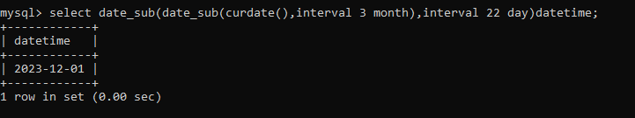

dynamic approach

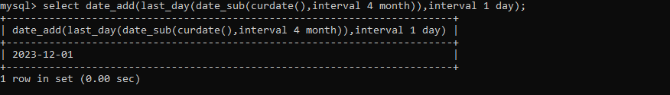

2. Write a query to display the last day of the month (in datetime format) three months before the current month.

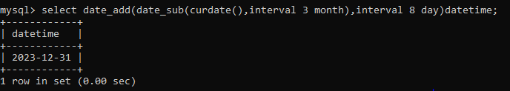

3. Write a query to get the distinct Mondays from hiredate in emp tables.

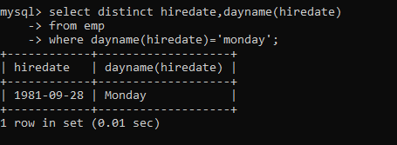

4. Write a query to get the first day of the current year.

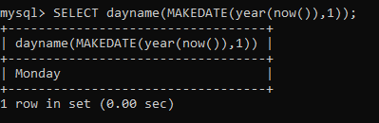

5. Write a query to get the last day of the current year.

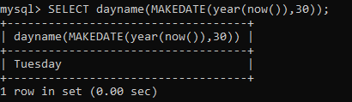

6. Write a query to calculate your age in year.

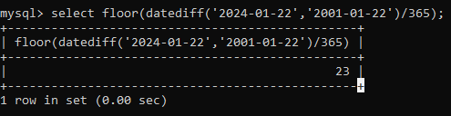

7. Write a query to get the current date in the following format.

Sample date : 04-sep-2014 Output : September 4, 2014

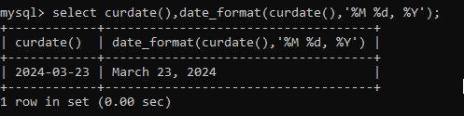

8. Write a query to get the current date in Thursday September 2014 format. Thursday September 2014

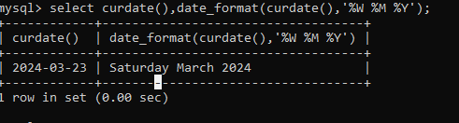

9. Write a query to extract the year from the current date.

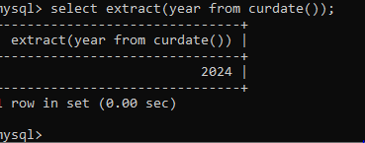

10. Write a query to get the first name and hire date from employees table where hire date between '1987-06-01' and '1987-07-30'

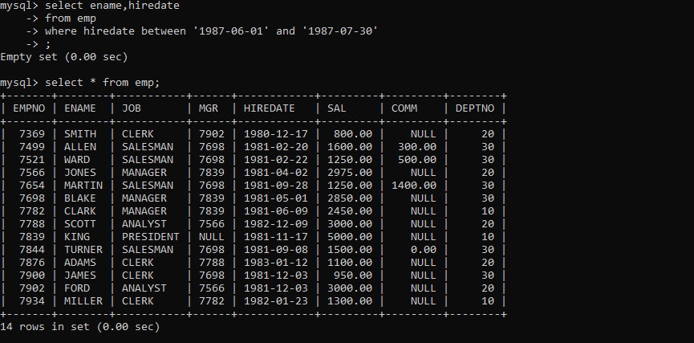

11. Write a query to display the current date in the following format. Sample output: Thursday 4th September 2014 00:00:00

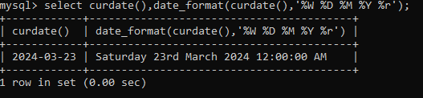

12. Write a query to display the current date in the following format. Sample output: 05/09/2014

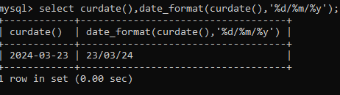

13. Write a query to display the current date in the following format. Sample output: 12:00 AM Sep 5, 2014

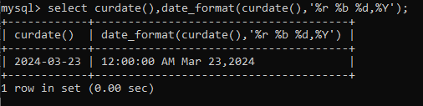

14. Write a query to get the employees who joined in the month of June.

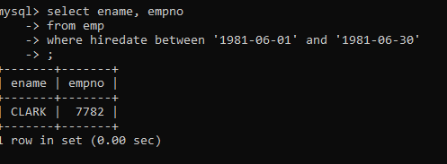

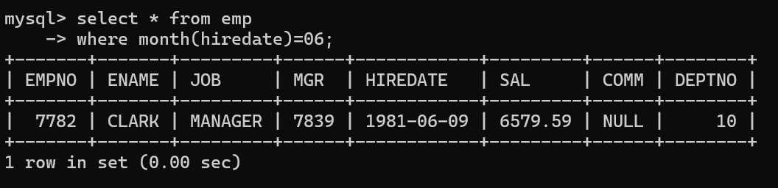se

15. Write a query to get the years in which more than 10 employees joined.

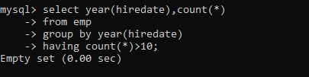

16. Write a query to get first name of employees who joined in 1987.

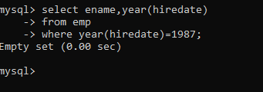

17. Write a query to get employees whose experience is more than 5 years.

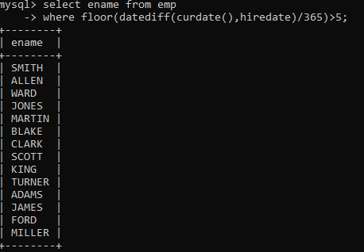

18. Write a query to get employee ID, last name, and date of first salary of the employees.

Select

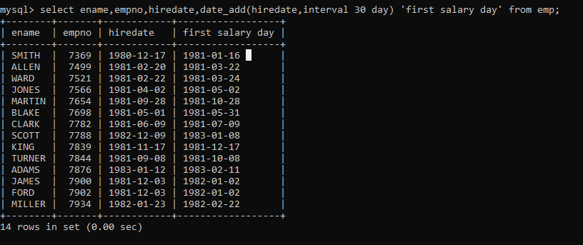

19. Write a query to get first name, hire date and experience of the employees. Sample table: employees

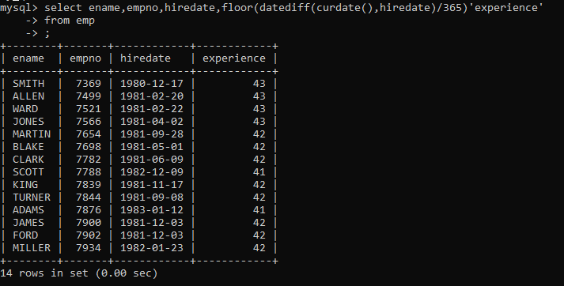

20. Write a query to get the department ID, year, and number of employees joined.

